LCM Test Tool Protocol Proposal
Application Note for 32-bit NuMicro® Family

Document Information
Abstract | The LCM Test Tool is the convenient tool to light on the LCM rapidly. It can export the dedicated text file to integrate with the same driver for different LCM, respectively. This document introduces the tool USB vendor command protocol and the exported text file contents in detail..
Apply to | N9H2x Series

The information described in this document is the exclusive intellectual property of
Nuvoton Technology Corporation and shall not be reproduced without permission from Nuvoton.

Nuvoton is providing this document only for reference purposes of NuMicro microcontroller based system design. Nuvoton assumes no responsibility for errors or omissions.
All data and specifications are subject to change without notice.

For additional information or questions, please contact: Nuvoton Technology Corporation.
www.nuvoton.com

Table of Contents
1. Table Introduction 4
1.1. Test Items for Startup 4
1.2. Mass Storage Flow 4
1.3. Command Block Wrapper (CBW) 5
1.4. Command Status Wrapper (CSW) 6
2. LCM Test Tool Vendor Command 7
2.1. USB IBR Connect – 0x06 (0x51) 7
2.2. LCM Test Tool Write – 0x63 8
2.3. LCM Test Tool Verify – 0x64 9
2.4. LCM Send Information – 0x71 10
LCM Type 10
Resolution 11
Pixel Clock Frequency 11
Frame Buffer Data Type 11
Horizontal Timing 11
Vertical Timing 12
Sync LCM Interface 12
MPU LCM Interface 12
Clock Polarity 12
Sync LCM Configuration Interface Select 13
Sync LCM SPI Configuration 13
Sync LCM I2C Configuration 14
LCM Internal Register Settings 14
Backlight Control 15
Reset Control 15
Hsync Vsync De Mode 15
2.5. LCM Image Information Begin to Write – 0x72 15
2.6. LCM Image Information Continue to Write – 0x73 16
2.7. LCM Run – 0x74 17
2.8. LCM Stop – 0x75 18
2.9. LCM Set Selected Register – 0x76 19
2.10. LCM Get Selected Register – 0x77 20
Send Register Index 21
Get Register Contents 21
3. Export File 22
3.1. File Contents 22
LCM Type – word offset 0x00 22
Resolution – word offset 0x01–0x02 22
Pixel Clock Frequency – word offset 0x03 22
Frame Buffer Data Type – word offset 0x04 22
Horizontal Timing – word offset 0x05-0x07 22
Vertical Timing – word offset 0x08 22
Sync LCM Interface – word offset 0x09 23
MPU LCM Interface – word offset 0x0A 23
Clock Polarity – word offset 0x0B 23
Configure Interface Select – word offset 0x0C 23
SPI Configure – word offset 0x0D-0x0F 23
I2C Configure – word offset 0x10-0x11 23
Backlight Control – word offset 0x12-0x13 24
Reset Control – word offset 0x14 24
Hsync Vsync De Mode Select – word offset 0x15 24
Register Number – word offset 0x16 24
Register Contents – word offset 0x17 ~ 24

Introduction
The download tool protocol is based on USB Mass Storage Class command. It will follow the USB mass storage standard protocol.

Test Items for Startup

Mass Storage Flow
The Command/Data/Statue Flow (Figure 1) shows the flow for Command Transport, Data-In, Data-Out and Status Transport.
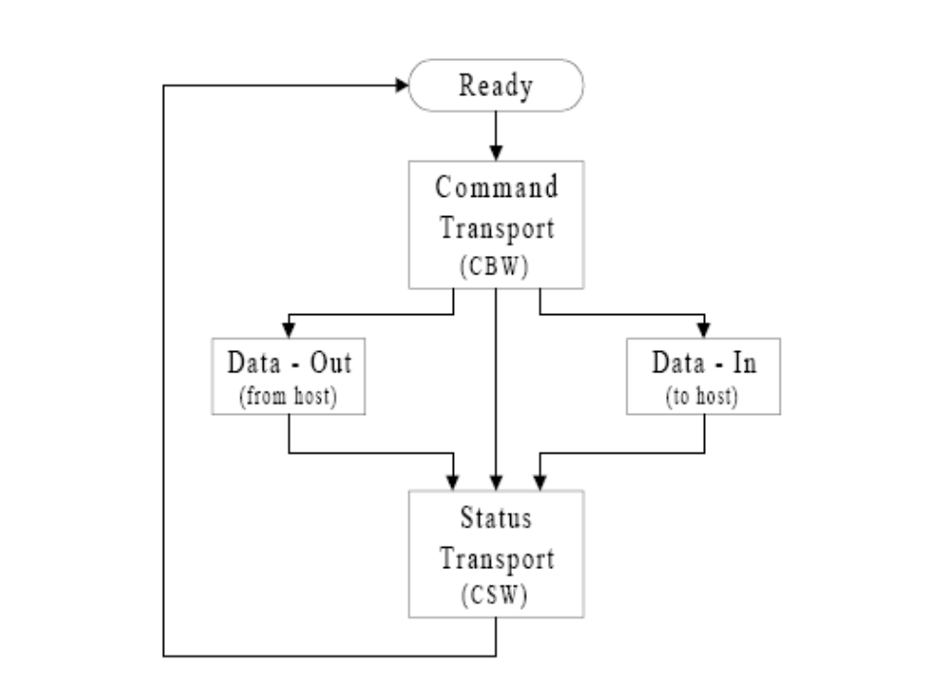
Figure 1 – Command/Data/Status Flow

Command Block Wrapper (CBW)
The CBW shall start on a packet boundary and shall end as a short packet with exactly 31 (1Fh) bytes transferred. The vendor command will follow the CBW definition.
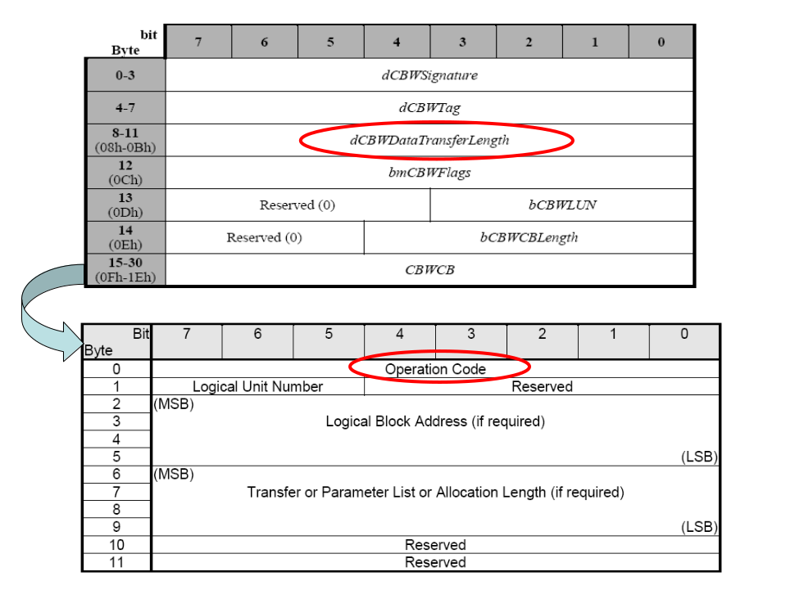
Figure 2 – Command Block Wrapper

Command Status Wrapper (CSW)
The CSW shall start on a packet boundary and shall end as a short packet with exactly 13 (0Dh) bytes transferred.
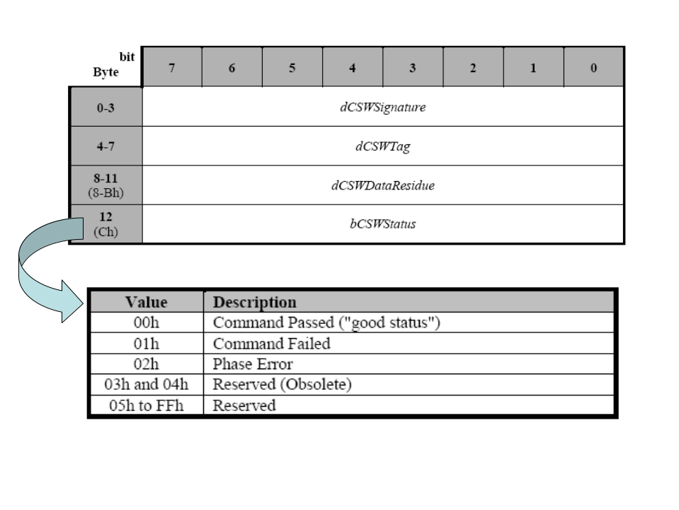
Figure 3 – Command Status Wrapper

LCM Test Tool Vendor Command
Describe the LCM Test Tool vendor command in detail.

USB IBR Connect – 0x06 (0x51)
This command is used to connect with IBR USB device. It will disable the timer counter without timeout.
- CBW Data transfer length – 8
- Operation Code – 0x06
- LUN – 0x51
- LBA (high byte) – 0x01 (Open); 0x02 (Close)

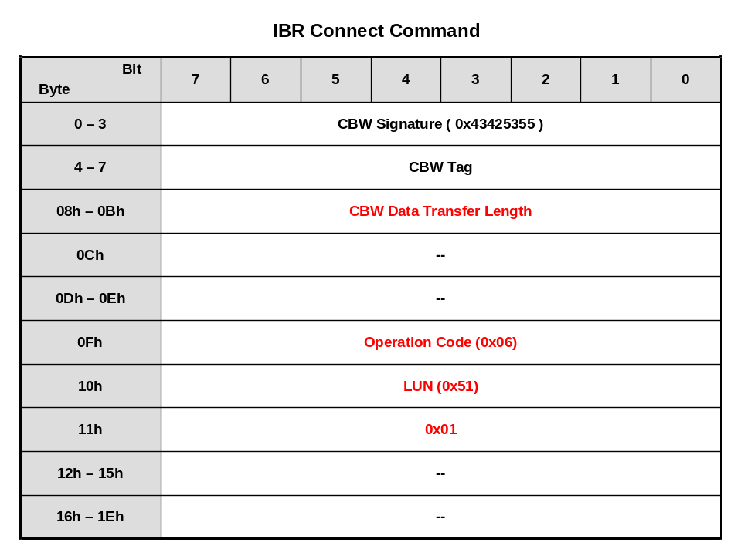

LCM Test Tool Write – 0x63
This command is used to select process functions.
- CBW Data transfer length – transfer length
- Operation Code – 0x63

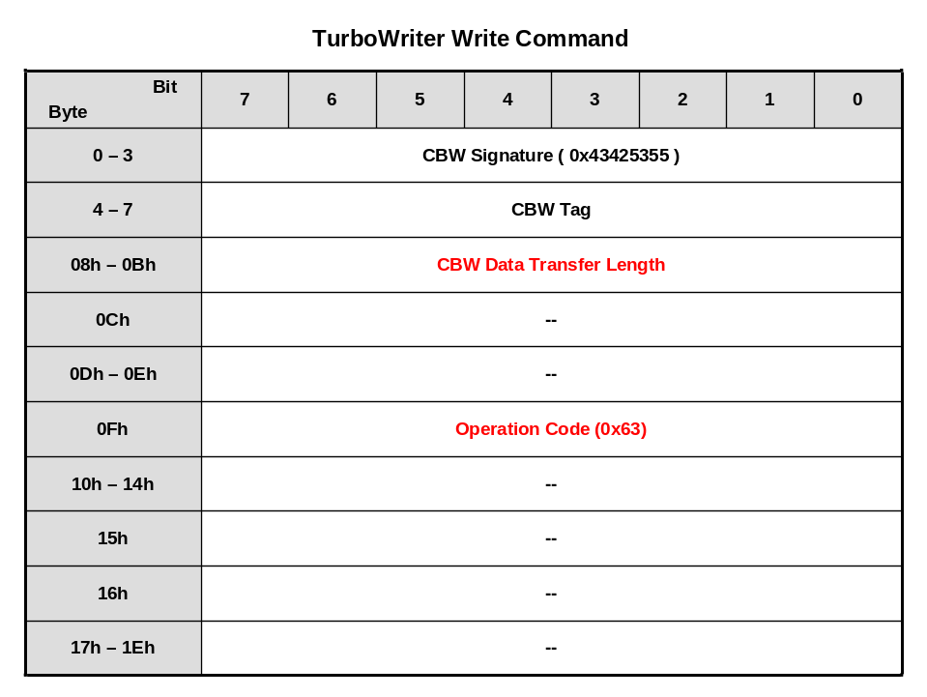

LCM Test Tool Verify – 0x64
This command is used to select process functions.
- CBW Data transfer length – transfer length
- Operation Code – 0x64

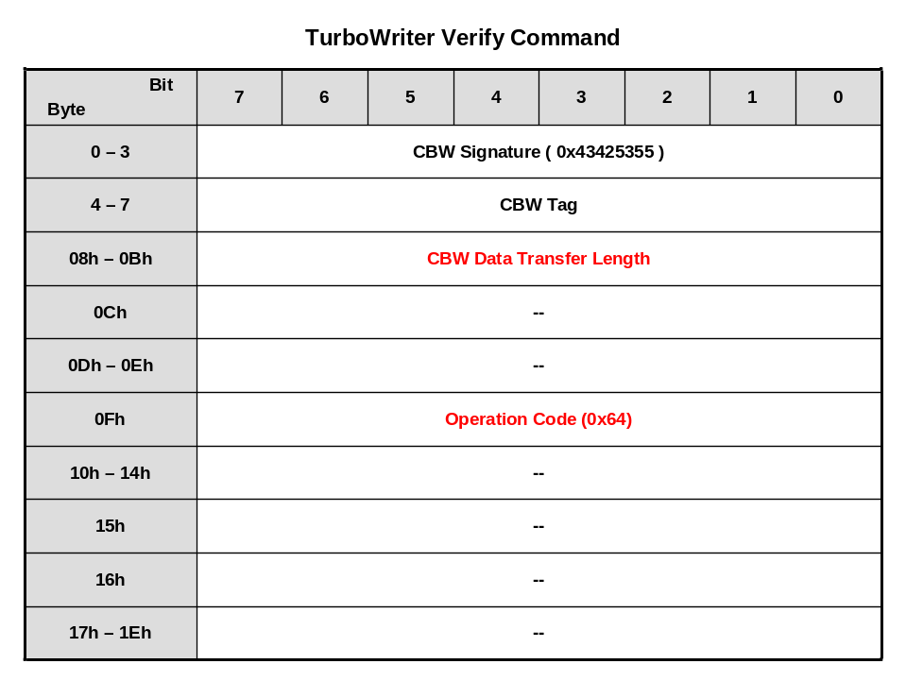

LCM Send Information – 0x71
This command is used to set LCM related information.
- CBW Data transfer length – structure length
- Operation Code – 0x71
- Parameters0 –
  - 0x00 – LCM Type
  - 0x01 – Resolution (for MPU & Sync LCM)
  - 0x02 – Pixel Clock Frequency (KHz, for Sync LCM)
  - 0x03 – Frame Buffer Data Type (for MPU & Sync LCM)
  - 0x04 – Horizontal Timing (for Sync LCM)
  - 0x05 – Vertical Timing (for Sync LCM)
  - 0x06 – Sync LCM Interface (for Sync LCM)
  - 0x07 – MPU LCM Interface (for MPU LCM)
  - 0x08 – Clock Polarity (for Sync LCM)
  - 0x09 – Sync LCM Configuration Interface Select (for Sync LCM)
  - 0x0A – Sync LCM SPI Configuration (for Sync LCM)
  - 0x0B – Sync LCM I2C Configuration (for Sync LCM)
  - 0x0C – LCM Internal Register Settings (for MPU & Sync LCM)
  - 0x0D – Backlight Control (for MPU & Sync LCM)
  - 0x0E – Reset Control (for MPU & Sync LCM)
  - 0x0F – Hsync Vsync DE Mode (for Sync LCM)

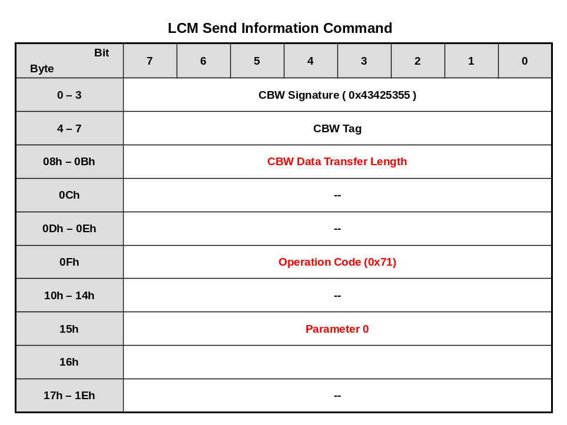

LCM Type
typedef enum {
reserved = 0,
eDRVVPOST_SYNC = 1, // default value
eDRVVPOST_MPU = 3
} E_DRVVPOST_LCM_TYPE;

E_DRVVPOST_LCM_TYPE eLcmType:
  - 0x01 – Sync Type LCM
  - 0x03 – MPU Type LCM

Resolution
typedef struct {
unsigned int u32PixelPerLine;
unsigned int u32LinePerPanel;
} S_DRVVPOST_LCM_WINDOW;

S_DRVVPOST_LCM_WINDOW sLcmWindow;

Pixel Clock Frequency
unsigned int u32PixelClock; (KHz)

Frame Buffer Data Type
typedef enum {
eDRVVPOST_FRAME_RGB555 = 0,
eDRVVPOST_FRAME_RGB565,
eDRVVPOST_FRAME_RGBx888,
eDRVVPOST_FRAME_RGB888x,
eDRVVPOST_FRAME_CBYCRY,
eDRVVPOST_FRAME_YCBYCR,
eDRVVPOST_FRAME_CRYCBY,
eDRVVPOST_FRAME_YCRYCB
} E_DRVVPOST_FRAME_DATA_TYPE;

E_DRVVPOST_FRAME_DATA_TYPE eFrameDataType;

Horizontal Timing
typedef struct {
unsigned int u32PulseWidth; // Horizontal sync pulse width
unsigned int u32BackPorch; // Horizontal back porch
unsigned int u32FrontPorch; // Horizontal front porch
} S_DRVVPOST_SYNCLCM_HTIMING;

S_DRVVPOST_SYNCLCM_HTIMING sHTiming;
  - The above settings are times the cycle of pixel clock.

Vertical Timing
typedef struct {
unsigned char u8PulseWidth; // Vertical sync pulse width
unsigned char u8BackPorch; // Vertical back porch
unsigned char u8FrontPorch; // Vertical front porch
} S_DRVVPOST_SYNCLCM_VTIMING;

S_DRVVPOST_SYNCLCM_VTIMING sVTiming;
  - The above settings are times the cycle of pixel clock.

Sync LCM Interface
typedef enum {
eDRVVPOST_RGB565 = 0, // default value
eDRVVPOST_RGB666,
eDRVVPOST_RGB888,
eDRVVPOST_CCIR601,
eDRVVPOST_RGBDummy,
eDRVVPOST_CCIR656,
eDRVVPOST_RGBThrough
} E_DRVVPOST_SYNCLCM_INTERFACE;

E_DRVVPOST_SYNCLCM_INTERFACE eSyncLcmInterface;

MPU LCM Interface
typedef enum {
eDRVVPOST_MPU_8_8 = 0,
eDRVVPOST_MPU_2_8_8,
eDRVVPOST_MPU_6_6_6,
eDRVVPOST_MPU_8_8_8,
eDRVVPOST_MPU_9_9,
eDRVVPOST_MPU_16,
eDRVVPOST_MPU_16_2,
eDRVVPOST_MPU_2_16,
eDRVVPOST_MPU_16_8,
eDRVVPOST_MPU_18,
eDRVVPOST_MPU_18_6,
eDRVVPOST_MPU_24
} E_DRVVPOST_MPULCM_DATABUS;

E_DRVVPOST_MPULCM_DATABUS eMpuLcmInterface;

Clock Polarity
typedef struct {
BOOL bHClock; // Hsync polarity
BOOL bVClock; // Vsync polarity
BOOL bDeClock; // DE polarity
BOOL bPixelClock; // pixel clock polarity
} S_DRVVPOST_CLK_POLARITY;

S_DRVVPOST_CLK_POLARITY sClockPolarity;

BOOL bHClock
  - 0x00 – clock active low
  - 0x01 – clock active high
BOOL bVClock
  - 0x00 – clock active low
  - 0x01 – clock active high
BOOL bDeClock
  - 0x00 – clock active low
  - 0x01 – clock active high
BOOL bPixelClock
  - 0x00 – clock active low
  - 0x01 – clock active high

Sync LCM Configuration Interface Select
typedef enum {
eDRVVPOST_SPI = 0,
eDRVVPOST_I2C_RESERVED,
eDRVVPOST_NONE
} E_DRVVPOST_CONFIG_INTERFACE;

E_DRVVPOST_CONFIG_INTERFACE eConfigInterface;
  - If “eDRVVPOST_NONE” selected, it means that need not configure LCM internal registers.

Sync LCM SPI Configuration
typedef enum {
eDRVVPOST_GPA = 0,
eDRVVPOST_GPB,
eDRVVPOST_GPC,
eDRVVPOST_GPD,
eDRVVPOST_GPE,
eDRVVPOST_GPF,
eDRVVPOST_GPG,
eDRVVPOST_GPH
} E_DRVVPOST_PORT_SELECT;

typedef enum {
eDRVVPOST_PIN_0 = 0,
eDRVVPOST_PIN_1,
eDRVVPOST_PIN_2,
eDRVVPOST_PIN_3,
eDRVVPOST_PIN_4,
eDRVVPOST_PIN_5,
eDRVVPOST_PIN_6,
eDRVVPOST_PIN_7,
eDRVVPOST_PIN_8,
eDRVVPOST_PIN_9,
eDRVVPOST_PIN_10,
eDRVVPOST_PIN_11,
eDRVVPOST_PIN_12,
eDRVVPOST_PIN_13,
eDRVVPOST_PIN_14,
eDRVVPOST_PIN_15
} E_DRVVPOST_PIN_SELECT;

typedef enum {
eDRVVPOST_SPI_WR = 0,
eDRVVPOST_SPI_RD
} E_DRVVPOST_SPI_OPERATION;

typedef struct {
E_DRVVPOST_PORT_SELECT eCSPort; // CS port
E_DRVVPOST_PIN_SELECT eCSPin; // CS pin
E_DRVVPOST_PORT_SELECT eClkPort; // clock port
E_DRVVPOST_PIN_SELECT eClkPin; // clock pin
E_DRVVPOST_PORT_SELECT eDataPort; // data port
E_DRVVPOST_PIN_SELECT eDataPin; // data pin
unsigned char u8SpiType; // reserved setting
unsigned char u8RegIndexWidth; // register index width, 8/16/24
unsigned char u8RegDataWidth; // register data width, 8/16/24
} S_DRVVPOST_SPI_CONFIGURE;

S_DRVVPOST_SPI_CONFIGURE sSpiConfigure;

Sync LCM I2C Configuration
typedef struct {
unsigned char u8I2C_ID; // I2C ID address
E_DRVVPOST_PORT_SELECT eClkPort; // clock port
E_DRVVPOST_PIN_SELECT eClkPin; // clock pin
E_DRVVPOST_PORT_SELECT eDataPort; // data port
E_DRVVPOST_PIN_SELECT eDataPin; // data pin
unsigned char u8RegIndexWidth; // register index width, 8/16/24
unsigned char u8RegDataWidth; // register data width, 8/16/24
} S_DRVVPOST_I2C_CONFIGURE;

S_DRVVPOST_I2C_CONFIGURE sI2cConfigure;

LCM Internal Register Settings
typedef struct {
unsigned int u32RegIndex; // register index
unsigned int u32RegData; // register data
} S_DRVVPOST_LCM_REG;

S_DRVVPOST_LCM_REG lcm_reg[n];

Backlight Control
typedef struct {
BOOL bDoNeedEnaPort; // check whether need to control backlight ENA pin
// 0: NO, 1: YES
E_DRVVPOST_PORT_SELECT eEnaPort; // Ena port
E_DRVVPOST_PIN_SELECT eEnaPin; // Ena pin
E_DRVVPOST_PIN_STATE eEnaStae;
BOOL bDoNeedPWMPort; // check whether need to control backlight PWM pin
// 0: NO, 1: YES
E_DRVVPOST_PORT_SELECT ePWMPort; // PWM port
E_DRVVPOST_PIN_SELECT ePWMPin; // PWM pin
E_DRVVPOST_PIN_STATE ePWMState;
} S_DRVVPOST_BACKLIGHT_CTRL;

S_DRVVPOST_BACKLIGHT_CTRL sBacklightCtrl;

Reset Control
typedef struct {
BOOL bDoNeedReset; // check whether need to reset LCM
// 0: NO, 1: YES
E_DRVVPOST_PORT_SELECT eResetPort; // RESET port
E_DRVVPOST_PIN_SELECT eResetPin; // RESET pin
E_DRVVPOST_PIN_STATE eResetStae;
} S_DRVVPOST_RESET_CTRL;

S_DRVVPOST_RESET_CTRL sResetCtrl;

Hsync Vsync De Mode
typedef enum {
eDRVVPOST_HSYNC_VSYNC_DE = 0, // LCM needs Hsync, Vsync and DE pins.
eDRVVPOST_HSYNC_VSYNC_ONLY, // LCM only needs Hsync and Vsync pins
eDRVVPOST_DE_ONLY // LCM only needs DE pin
} E_DRVVPOST_HSYNC_VSYNC_DE_MODE;

E_DRVVPOST_HSYNC_VSYNC_DE_MODE eHsyncVsyncDeMode;

LCM Image Information Begin to Write – 0x72
This command is used to begin sending image information (image binary data, for example, RGB565, RGB888, …).
- CBW Data transfer length – transfer length
- Operation Code – 0x72

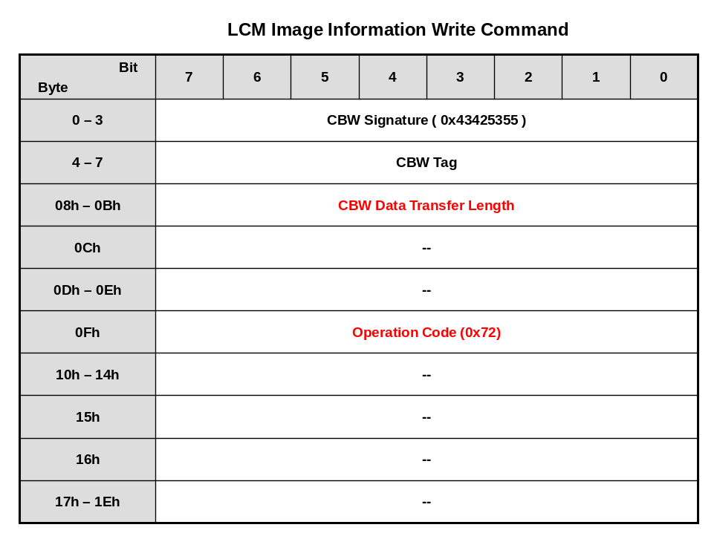

LCM Image Information Continue to Write – 0x73
This command is used to continue sending image information (image binary data, for example, RGB565, RGB888, …).
- CBW Data transfer length – transfer length
- Operation Code – 0x73

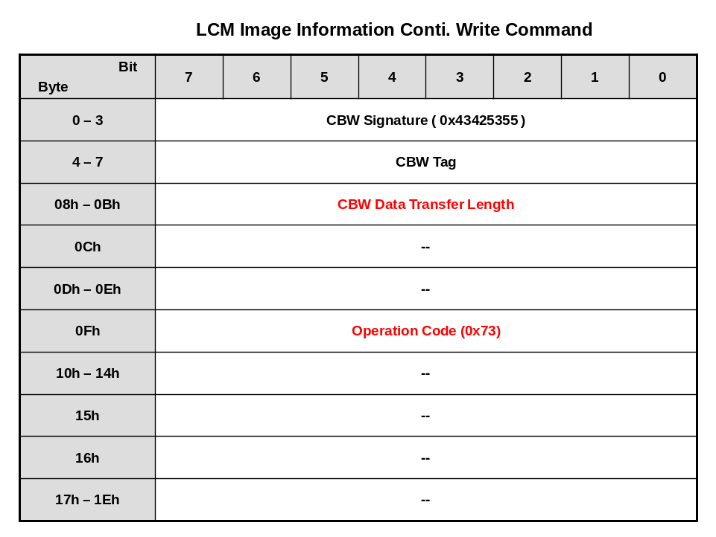

LCM Run – 0x74
This command is used to begin LCM display.
- CBW Data transfer length – transfer length = 0
- Operation Code – 0x74

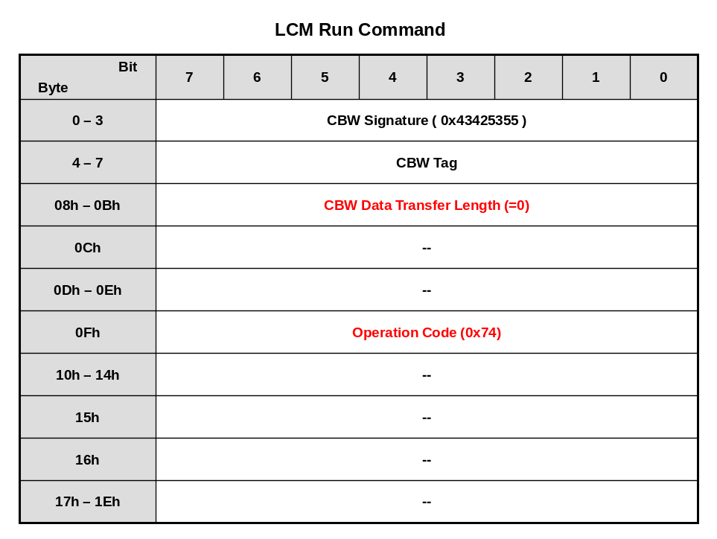

LCM Stop – 0x75
This command is used to stop LCM display.
- CBW Data transfer length – transfer length = 0
- Operation Code – 0x75

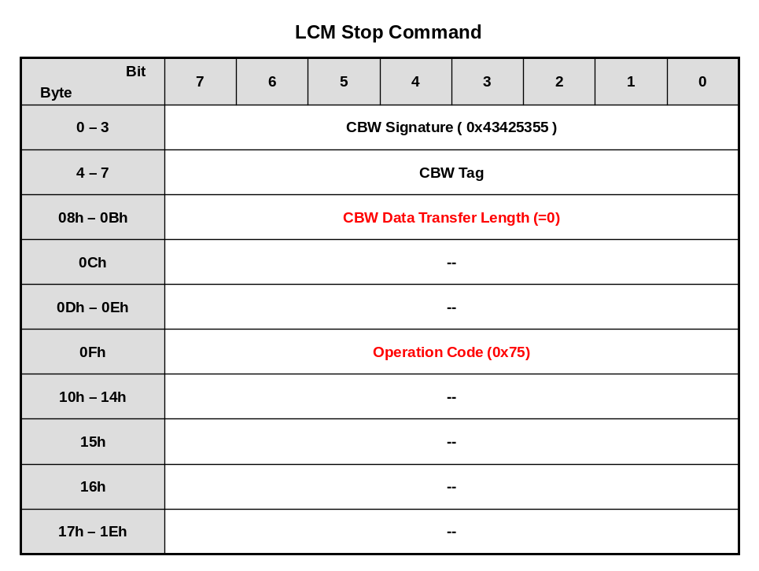

LCM Set Selected Register – 0x76
This command is used to set the selected LCM internal register.
- CBW Data transfer length – transfer length
- Operation Code – 0x76

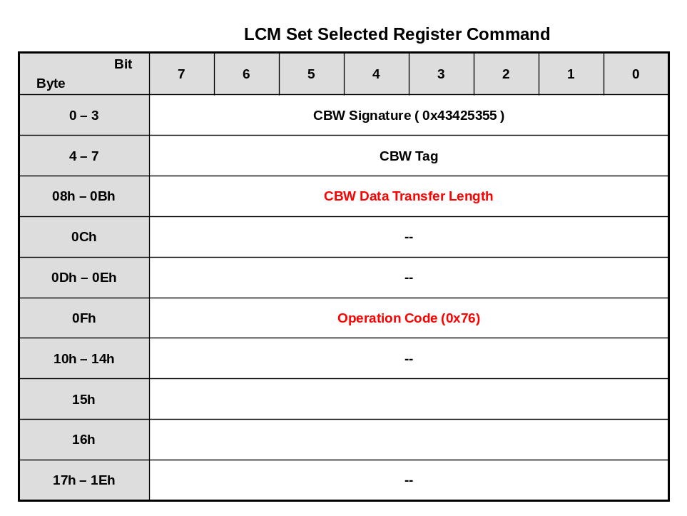

Sent data after CBW

E_DRVVPOST_LCM_TYPE eLcmType (1-byte);
E_DRVVPOST_MPULCM_DATABUS eMpuLcmInterface (1-byte);
E_DRVVPOST_CONFIG_INTERFACE eConfigInterface (1-byte);
S_DRVVPOST_SPI_CONFIGURE sSpiConfigure (9-byte);
S_DRVVPOST_I2C_CONFIGURE sI2cConfigure (7-byte);
Reserved (1-byte);
S_DRVVPOST_LCM_REG lcm_reg (8-byte);

LCM Get Selected Register – 0x77
This command is used to get the selected LCM internal register.
- CBW Data transfer length – transfer length
- Operation Code – 0x77
- Parameters0 –
  - 0x00 – Send the register index and related information
  - 0x01 – Get the register contents.

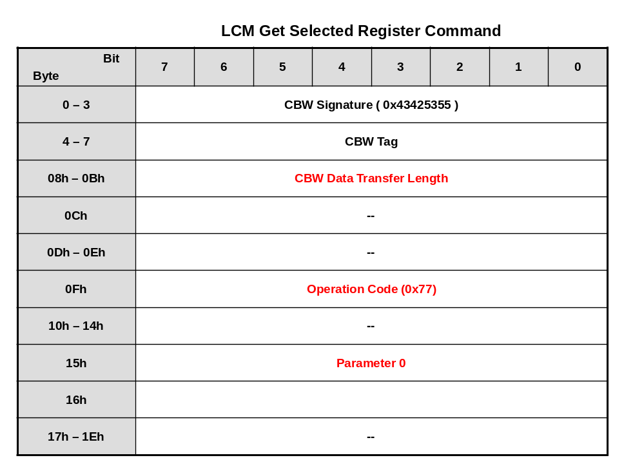

Send Register Index
E_DRVVPOST_LCM_TYPE eLcmType (1-byte);
E_DRVVPOST_MPULCM_DATABUS eMpuLcmInterface (1-byte);
E_DRVVPOST_CONFIG_INTERFACE eConfigInterface (1-byte);
S_DRVVPOST_SPI_CONFIGURE sSpiConfigure (9-byte);
S_DRVVPOST_I2C_CONFIGURE sI2cConfigure (7-byte);
Reserved (1-byte);
unsigned int u32RegIndex (4-byte);

Get Register Contents
unsigned int u32RegData (4-byte);

Export File
After using the above vendor command, the related LCM settings can be exported to become an initial file. The LCM driver can include this file to light on the LCM smoothly.

File Contents
The exported file contents will be arranged as follows.

LCM Type – word offset 0x00
This word is the selected LCM type.
  - Word offset 0x00 – LCM type

Resolution – word offset 0x01–0x02
These words will record the LCM resolution.
  - Word offset 0x00 – pixels per line
  - Word offset 0x01 – lines per panel

Pixel Clock Frequency – word offset 0x03
It is the pixel clock frequency.
  - Word offset 0x00 – pixel clock frequency

Frame Buffer Data Type – word offset 0x04
This word records the frame buffer data type. For example, RGB555, RGB565, YUV and so on.
  - Word offset 0x00 – frame buffer data type

Horizontal Timing – word offset 0x05-0x07
These words will record the horizontal timing.
  - Word offset 0x00 – horizontal sync pulse
  - Word offset 0x01 – horizontal back porch
  - Word offset 0x02 – horizontal front porch

Vertical Timing – word offset 0x08
This word will record the vertical timing.
  - Byte offset 0x00 – vertical sync pulse
  - Byte offset 0x01 – vertical back porch
  - Byte offset 0x02 – vertical front porch

Sync LCM Interface – word offset 0x09
This word records the sync interface. For example, RGB interface (i.e., RGB565, RGB666 and RGB888), CCIR601, CCIR656 and so on.
  - Word offset 0x00 – sync LCM interface

MPU LCM Interface – word offset 0x0A
This word records the MPU interface. For example, MPU_8_8, MPU_16 and so on.
  - Word offset 0x00 – MPU LCM interface

Clock Polarity – word offset 0x0B
This word is the clock polarity setting.
  - Byte offset 0x00 – horizontal clock polarity
  - Byte offset 0x01 – vertical clock polarity
  - Byte offset 0x02 – DE clock polarity
  - Byte offset 0x03 – pixel clock polarity

Configure Interface Select – word offset 0x0C
This word is for the configure interface selection. For example, SPI or I2C or none.
  - Word offset 0x00 – configure interface selection

SPI Configure – word offset 0x0D-0x0F
These words are for SPI configuration settings.
  - Byte offset 0x00 – port selection for SPI CS pin. 0: GPA, 1: GPB and so on
  - Byte offset 0x01 – pin selection for SPI CS pin. 0: pin-0, 1: pin-1 and so on
  - Byte offset 0x02 – port selection for SPI CLK pin. 0: GPA, 1: GPB and so on
  - Byte offset 0x03 – pin selection for SPI CLK pin. 0: pin-0, 1: pin-1 and so on
  - Byte offset 0x04 – port selection for SPI DAT pin. 0: GPA, 1: GPB and so on
  - Byte offset 0x05 – pin selection for SPI DAT pin. 0: pin-0, 1: pin-1 and so on
  - Byte offset 0x06 – SPI type setting
  - Byte offset 0x07 – LCM internal register index width
  - Byte offset 0x08 – LCM internal register data width

I2C Configure – word offset 0x10-0x11
These words are for I2C configuration settings.
  - Byte offset 0x00 – port selection for I2C CLK pin. 0: GPA, 1: GPB and so on
  - Byte offset 0x01 – pin selection for I2C CLK pin. 0: pin-0, 1: pin-1 and so on
  - Byte offset 0x02 – port selection for I2C DAT pin. 0: GPA, 1: GPB and so on
  - Byte offset 0x03 – pin selection for I2C DAT pin. 0: pin-0, 1: pin-1 and so on
  - Byte offset 0x04 – LCM internal register index width
  - Byte offset 0x05 – LCM internal register data width

Backlight Control – word offset 0x12-0x13
These words are for backlight control settings.
  - Byte offset 0x00 – indicates to control backlight ENA pin or not. 0: NO, 1: YES
  - Byte offset 0x01 – port selection for ENA pin. 0: GPA, 1: GPB and so on
  - Byte offset 0x02 – pin selection for ENA pin. 0: pin-0, 1: pin-1 and so on
  - Byte offset 0x03 – if needs to control ENA pin, it indicates the pin state. 0: LOW, 1: HIGH
  - Byte offset 0x04 – indicates to control backlight PWM pin or not. 0: NO, 1: YES
  - Byte offset 0x05 – port selection for PWM pin. 0: GPA, 1: GPB and so on
  - Byte offset 0x06 – pin selection for PWM pin. 0: pin-0, 1: pin-1 and so on
  - Byte offset 0x07 – if needs to control PWM pin, it indicates the pin state. 0: LOW, 1: HIGH

Reset Control – word offset 0x14
These words are for reset control settings.

  - Byte offset 0x00 – indicates to control LCM RESET pin or not. 0: NO, 1: YES
  - Byte offset 0x01 – port selection for RESET pin. 0: GPA, 1: GPB and so on
  - Byte offset 0x02 – pin selection for RESET pin. 0: pin-0, 1: pin-1 and so on
  - Byte offset 0x03 – if needs to control RESET pin, it indicates the RESET active state. 0: LOW, 1: HIGH

Hsync Vsync De Mode Select – word offset 0x15
This word indicates that the LCM needs how many sync signals for display.
  - Word offset 0x00 – Hsync, Vsync and DE mode selection

Register Number – word offset 0x34
This word indicates how many LCM registers need to be configured.
  - Word offset 0x00 – indicates how many LCM registers

Register Contents – word offset 0x35 ~
These words record the configured register contents.
  - Word offset 0x00 – LCM register index
  - Word offset 0x01 – LCM register data
  - Word offset 0x02 – LCM register index
  - Word offset 0x03 – LCM register data
  - …
The total register number is indicated in the above register number (word offset 0x16)

Revision History
Date | Revision | Description
May 10, 2019 | 1.00 | Initially issued.

Important Notice
Nuvoton Products are neither intended nor warranted for usage in systems or equipment, any malfunction or failure of which may cause loss of human life, bodily injury or severe property damage. Such applications are deemed, “Insecure Usage”.
Insecure usage includes, but is not limited to: equipment for surgical implementation, atomic energy control instruments, airplane or spaceship instruments, the control or operation of dynamic, brake or safety systems designed for vehicular use, traffic signal instruments, all types of safety devices, and other applications intended to support or sustain life.
All Insecure Usage shall be made at customer’s risk, and in the event that third parties lay claims to Nuvoton as a result of customer’s Insecure Usage, customer shall indemnify the damages and liabilities thus incurred by Nuvoton.

